Foundation for Virtual and Augmented Reality Systems
Prof. Samit Bhattacharya
Department of Computer Science and Engineering
Indian Institute of Technology, Guwahati
Week – 10
Lecture – 49
VR experience optimisation
Hello and welcome to the NPTEL MOOCs course on Foundations for Virtual and Augmented Reality Systems. Now we are going to start a new topic, which is Optimizing VR Navigation Experience. Before we start, let us quickly recap what we have learned so far. In our learning so far, we have mostly focused on the foundational aspects of extended reality systems, which included the idea of VR systems, namely the hardware and software used to build such systems, and also extended reality systems in general, including AR systems, the role of human factors, how they are important, why we should bother about them, and how they can be taken into account while building extended reality systems. We have also learned about the design lifecycle for any extended reality system. There we talked about interactive systems. Extended reality systems are essentially a subset of interactive systems. And we talked about the interactive system development lifecycle.
Primarily we focused on the requirement gathering, the design-prototype-evaluate cycle, that is, interface and interaction design, where we learned about design guidelines, prototyping, and expert evaluation techniques. Also, we talked about implementation and usability evaluation of such systems. Now, all these concepts pertain to usable system development.
So, essentially, our objective is to build systems that are usable, and in order to do so, whatever we needed to know, whatever we needed to use, all those basic things we have covered so far, with the objective that we should be able to enhance the user experience. Now, the considerations that we have covered so far, the topics that we have covered so far, are important considerations, no doubt. But there are more such important considerations to be taken into account while building systems.
So, usability is something that rests on many things. We have covered a few of those, and there are many other such considerations, when we are talking of usable system development and deployment. Now, other considerations can broadly be related to the issues of optimization. So, we are going to devote time to understanding what these issues of optimization are.
Here, in these lectures, we will primarily focus on optimization in VR, immersive experience in particular. Now, we can look at this optimization problem, the issues of optimization, from two perspectives. One is optimized experience, that is, psychophysiological experience optimization. The other one is optimized resource utilization or resource requirement, that is, technological optimization.
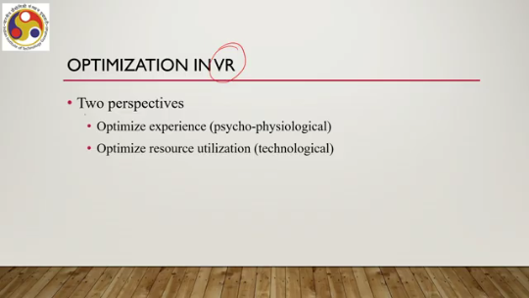
So, these two perspectives we can think of while talking about optimization in VR. These two optimization requirements are there in any XR system, of course, but the thing is that in an immersive experience, the optimization requirements gain more prominence. So, we will be focusing mostly on immersive VR experience, and immersive VR systems while dealing with optimization issues. So, let us first talk about experience optimization.
Now, earlier we talked about a major issue in immersive VR, that is the issue of cyber sickness. When we talk about an optimized experience, one way to look at it is to design the experience so as to minimize cyber sickness. So, when we are trying to minimize cyber sickness or minimize the possibility of the induction of cyber sickness while using a system, then we can roughly call it an experience optimization problem. What is the other one? Resource optimization.
So, in XR or extended reality in general and VR in particular. The systems are generally resource-hungry. To get some idea of what this means, you can recap our discussion on the VR hardware and software where we talked about the hardware requirements, what kind of hardware we need to suitably deploy VR systems in particular. Now, if the requirement is too high, then certainly the systems will not be affordable, and it will be difficult to make products for the masses where affordability is a major concern. So, we should aim to build systems to minimize resource requirements as well while trying to minimize cyber sickness. Now, while trying to minimize resource requirements, we should not compromise on experience. We should try to maximize the immersive experience; then only we can say that this resource optimization is effective. Otherwise, we may optimize resources, but if that affects the experience, then we cannot call it optimization.
So, our goal is to build and deploy VR systems with as few resources as possible, without compromising on experience or without reducing the quality of experience to the extent possible. Of course, when we are trying to optimize two things, one is resource requirements and the other one is experience, we have to balance some trade-offs, and balancing those trade-offs is the optimization that we are talking about here. So, in this lecture, we will talk about ways to optimize experience.
We will not focus on the resource optimization part here. In order to understand resource optimization, we require a detailed discussion on certain relevant things, which we will take up in subsequent lectures. This lecture will focus on experience optimization. Now, as we have already talked, when we talk of experience optimization, particularly in the context of VR, we are essentially referring to the fact that we are trying to minimize cyber sickness.
So, experience optimization essentially can be equated with optimizing cyber sickness. Before we delve deeper into the experience optimization techniques, let us quickly recap what cyber sickness is. As you may recollect, it is also known as visually induced motion sickness, or VIMS, which is a condition that can affect individuals when they interact with virtual reality technologies and can be caused by a variety of factors. So, it is not a single-factor effect; a variety of factors can affect the cyber sickness in a user.
So, what are those causes of cyber sickness? So, there are broadly two categories of factors we can relate to the induction of cyber sickness: internal factors and external factors. External factors can broadly be divided into hardware and VR content categories for cyber sickness. Now, under internal factors, we have several factors such as the age of the user, the gender of the user, susceptibility to motion sickness of the user, the physical condition of the user, and the emotional condition also of the user.
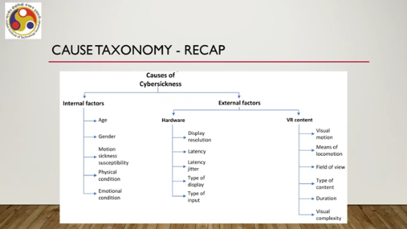
So, these five are primarily responsible for cyber sickness in a user, which can be categorized under internal factors, internal to the user. Now, among the external factors, we have hardware, under which there is display resolution, latency, latency jitter, type of display, and type of input, which are primarily considered to be responsible for cyber sickness. Under VR content, we have visual motion, means of locomotion, field of view, type of content, duration, and visual complexity, which are responsible for cyber sickness. Of course, for details of each of these factors, you can refer to our earlier discussion on cyber sickness.
We had a very detailed discussion on cyber sickness. Please refer to those. Now, finding a feasible solution to reduce the impact of cyber sickness on a user is extremely important for two reasons. It is supposed to greatly enhance overall user experience and make VR more appealing to a wider range of people.
So, it is very important to find solutions to address the cyber sickness issue while the user is experiencing a VR system. Now, solutions to address cyber sickness issues broadly come under the mitigation strategies for mitigation of cyber sickness. Now, these mitigation strategies often come at the cost of presence; that is, if we try to reduce cyber sickness, then the presence may be reduced. That is, the user will feel more like in an artificial environment than a real environment.
So, the user will be less likely to get a proper immersive experience. Now, this is where the challenge lies: developing mitigation strategies without compromising on user experience. So, our motto is that we should try to develop cyber sickness mitigation strategies, but at the same time, we should not compromise on presence, which indirectly is related to user experience.
So, what we are going to learn in this lecture is we will try to understand how to minimize cyber sickness by minimizing the duration or distance covered in navigation. So, what we are going to learn is basically minimizing cyber sickness by minimizing the duration of navigation in the virtual environment or minimizing distance in navigation during the virtual experience. Now, while we are trying to minimize either of these, duration or distance covered, we should keep in mind that we should not compromise on presence. So, our objective is to try to minimize duration or distance in navigation while trying to maximize presence.
So, then it brings us to the issue of VR navigation. So, we are trying to optimize user experience. In immersive systems, in order to do so, we are trying to minimize cyber sickness without compromising on presence. And we are trying to minimize cyber sickness by minimizing the duration of exposure to the virtual world or, by minimizing the distance covered in the virtual world during navigation in the virtual world.
While doing so, we try to maximize presence. Now, since we are talking of navigation, the duration or distance covered in navigation, let us quickly have a recap on VR navigation. We have already had a detailed discussion on VR navigation earlier. Let us just have a quick recap. To navigate in the VR world, we use virtual locomotion techniques or in short, VLTs. Now, when you talk of VLTs, there are different categories of virtual locomotion techniques, as we have discussed earlier in detail. We have walking-based locomotion techniques where physical walking is involved, under which we can have full gait, partial gait, and gait negation techniques. Then we have steering-based locomotion techniques, selection-based locomotion techniques, and finally, manipulation-based locomotion techniques.
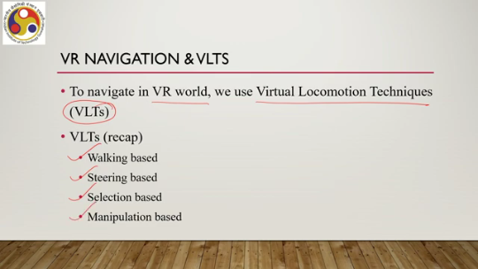
So, broadly, these four categories of techniques are utilized for locomotion in the virtual world, that is, moving from one point to another. Now, VLTs allow us to perform navigation in the VR world. In other words, we can say that VLTs allow us to perform a VR tour, or virtual reality tour, in the virtual environment. Now, these virtual reality tours, based on the way they are made, can be categorized into two broad groups. One is user-controlled virtual tours.
The second one is system-controlled virtual tours. In the case of user-controlled virtual tours, what do we perform? So, user-controlled tours essentially refer to a tour in which the user has control over their travel and navigation within the VR environment. So, the user can control how to navigate, where to navigate; the user has full control of their navigation in the virtual world. That is a user-controlled VR tour. It typically involves
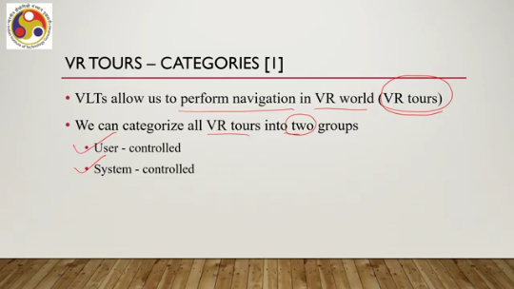
controllers or other input modalities to move and explore virtual space according to the preferences and actions of the user. So, some means of interaction must be there. As opposed to that, we have system-controlled virtual tours. Here, the system or application is in control of the user's travel within the VR environment.
So, in the case of a user-controlled tour, the user is controlling how to move and where to move, whereas in the case of a system-controlled tour, the system is controlling how the user is moving in the virtual world and where the user is moving. So, the user's movement and navigation are guided or controlled by the system itself. Unlike in the previous case, where the user is controlling the movement and navigation. Now, since the system is controlling the user's movement, such techniques or such VR tools often follow a predetermined path or sequence of movements.
It is already decided which way to move and where to move. Now, like any other system, we have positives and negatives for system-controlled tools as well. On the positive side, we have this positive effect: that is, system-controlled tools are often an effortless experience with reduced cognitive demands, allowing the users to concentrate more on the experience itself. Why is the cognitive demand reduced?
The user does not have to decide which way to move, how to move, or any of those things. The system takes care of those decision-making things. So the user is free to choose to experience, to concentrate more on the experience itself rather than spend time on planning to move. On the negative side, what is there? Lack of user involvement makes them less realistic.
So since the user is unable to control the movement, the user feels like it is not real. It is a system in which the user is experiencing the thing which defeats the very purpose of presence. Whatever that is, whatever positive and negative sides it has. So, in this lecture, we will be focusing on system-controlled tours.
More specifically, we will be focusing on realistic walking experiences in system-controlled tours. So, while the navigation is taking place in a system-controlled tour, the user should not feel like they are actually being controlled by the system. Instead, if the walking experience or navigation experience is realistic, the user will forget, or the difference between the realistic and unrealistic things will vanish, will reduce in the mind of the user.
So, our objective is to have a realistic walking experience in a system control tool so that the user feels present in the tool. Subsequently, we will see how that realistic walking experience approach that we can adopt to make the user feel present in the tool can be utilized to optimize user experience. So, why are we focusing on a realistic walking experience? Now, improving the walking experience in VR tours is vital for enhanced realism, or in other words, enhanced presence.
For that, it is essential to use the user's actual walking speed as the travel speed. So, when the user is navigating in a system-controlled tour, that is, the system is forcing the user to move from one place to another, the speed at which the user is moving should match the user's real-world experience. Now, here we are assuming that the navigation is taking place as if the user is walking. Of course, that is not necessarily the case always.
However, in our case, we are assuming that the user is navigating through walking, and it is essential to use the user's actual walking speed to give the user a feel of realism. Now, when you say 'actual,' it refers to the user's typical walking behavior, not during walking in a VR tour. So, the challenge here is that system-automated tours typically do not allow for continuous user input. So, that makes it difficult to align the user's input with the walking speed. So, if the input mechanism is not there, then how do we tell
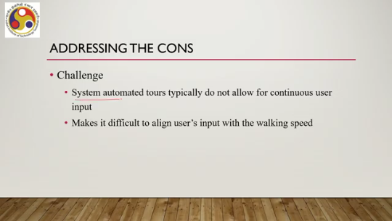
or how the user can tell whether they want to move at a natural walking speed or whether the speed being provided by the system is good enough. So, one way out can be a constant walking speed as an optic flow, or in other words, the speed of change of the scene. So, how do we perceive that somebody is moving? We perceive our movement by perceiving the change in our view of the surroundings.
In other words, change in the scene. Now, in a virtual world, a virtual tour, the same thing happens. When I say the user is moving or navigating, that means the scene is changing constantly. Now, the speed at which the scene changes needs to match the user's realistic walking speed. Otherwise, it will look unrealistic.
It may be very fast or very slow. Now, One way to make it look more realistic is to have a constant walking speed as an optic flow; that is, the speed at which the scenes change remains constant over time. But this is not very realistic, of course, as we can intuitively understand, because when we move, we rarely follow a constant speed while walking. We ourselves do not do it.
So, if the system is doing so, there is less possibility that we will feel realistic while exploring the virtual space. Now, our objective is to have a more realistic experience. In other words, we are trying to display a visual speed or optic flow that matches the user's instantaneous walking speed. So, essentially, what we are trying to figure out is a model of the user's walking speed. How typically a user moves and what is the instantaneous speed during movement, and accordingly, we should try to change the scenario, the visual scene in the virtual world.
Then it may give the user a realistic feeling. So, in the next part of the lecture, we are going to learn about such a model which can provide an idea of the instantaneous walking speed, and correspondingly, we can have a more realistic walking experience. However, that we will take up in the next part of the lecture. So, let us summarize what we have covered so far.
We talked about the idea of optimization in VR; there we talked about two optimizations: psychophysiological and technological. Now, the psychophysiological optimization, we essentially equated it with the VR experience optimization. Further, we equated it with optimizing cyber sickness prevalence; that is, we want to minimize cyber sickness while the user is experiencing the immersive system. So, that is the way we have framed the optimization problem.
How do we minimize cyber sickness? And in order to do so, we assume that we are talking about system-controlled VR tools where the user is navigating through walking and we want to give the user a realistic walking experience so that the user feels present in the system. When we try to optimize cyber sickness, of course, presence is very important. If we compromise on presence, then whether you optimize cyber sickness or not, essentially the quality of experience will deteriorate.
So, taking care of presence is very important. Towards that direction, we are trying to have a natural walking experience in the VR world, in a system-controlled VR tour. In the next part of the lecture, we are going to talk about models for optimization which include a description of a model for natural walking experience. I hope you could follow the topic, you could follow the concepts. Looking forward to meeting you in the next part of the lecture.
Till then, thank you, goodbye and happy learning.

